<http://www.rainforestnet.com/datetimepicker/datetimepicker-tutorial.htm>

JavaScript Date Time Picker

Get Started (Download)

1. First of all, Please [Download](http://www.rainforestnet.com/datetimepicker/download/sample.zip) a 12kb compressed file, "sample.zip". Extract the compressed file into your preferred directory.

2. Place "datetimepicker_css.js" file in your web page directory or subdirectory.

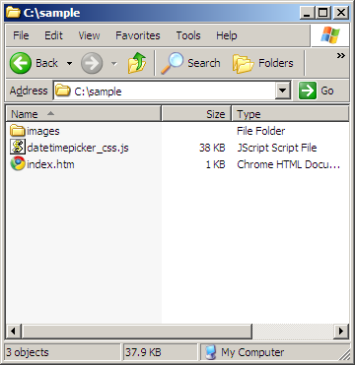

3. From version 2.0 onwards, Javascript Date Time Picker includes couples of small image files which have to be placed under "images" directory. (You may also choose not to use images file, please see "Configuration" section)

4. Make a reference to "datetimepicker_css.js" in your HTML page header. Assume that "datetimepicker_css.js" is in the same directory with your html file.

<!DOCTYPE html>  
<html lang="en">  
<head>  
   <title>Javascript Date Time Picker Demo Page</title>  
   <script src="datetimepicker_css.js"></script>  
</head>  
<body>  
  
   <div style="text-align:center; margin:150px auto 100px auto;">  
     <label for="demo1">Please enter a date here &gt;&gt; </label>  
     <input type="Text" id="demo1" maxlength="25" size="25"/>  
     <img src="images/cal.gif" onclick="javascript:NewCssCal('demo1')" style="cursor:pointer"/>  
   </div>  
  
</body>  
</html>

5. Create a textbox for user to enter date/time value. Make sure you assign an unique element id to your textbox element. In my case, the unique element id is "demo1"

<input type="Text" id="demo1" maxlength="25" size="25"/>

6. Our objective is to make a Calendar appears to assist user to pick a Date whenever user click on a calendar icon. The calendar icon file ("cal.gif") is included in "sample.zip". What you need to do is to add an "onclick" event to call the JavasCript Calendar object.

<img src="images/cal.gif" onclick="javascript:NewCssCal('demo1')" style="cursor:pointer"/>

7. It is that easy. Check out the sample page [here](http://www.rainforestnet.com/datetimepicker/sample/index.htm). If what you see in the sample page is fine for you, you are done. If not, you may want to find out how to configure JavaScript Date Time Picker. Click [here](http://www.rainforestnet.com/datetimepicker/datetimepicker-config.htm).

JavaScript Date Time Picker

Instance Level

From ["Get Started"](http://www.rainforestnet.com/datetimepicker/datetimepicker-tutorial.htm) page, we knew that we just need to call JavaScript function "NewCssCal('demo1')" to invoke the Calendar and you can subsequently pick a date to fill the input textbox.

"demo1" being the input textbox element id.

<input type="Text" id="demo1" maxlength="25" size="25"/>  
<img src="images/cal.gif" onclick="javascript:NewCssCal('demo1')" style="cursor:pointer"/>

The main JavaScript function "NewCssCal" has more than one argument.

NewCssCal(

[Textbox element ID] ,

[Date format] ,

[Navigation pattern] ,

[Display time in calendar] ,

[Time mode] ,

[Show Seconds] ,

[Enable future date or past date]

)

Remember! The ONLY Mandatory argument is "Text element ID". The rest of arguments will fallback to default value if unspecified.

| **Arguments** | **Default** | **Possible values** |
| --- | --- | --- |
| [Textbox element ID] |  |  |
| [Date Format] | MMddyyyy | 'ddMMyyyy' or 'ddMMMyyyy' or 'MMddyyyy' or 'MMMddyyyy' or 'yyyyMMdd' or 'yyyyMMMdd' |
| [Navigation pattern]* | 'dropdown' | 'dropdown' or 'arrow' |
| [Display time in calendar] | false | true or false |
| [Time mode] | 24 | 12 or 24 |
| [Show Seconds] | false | true of false |
| [Enable future date or past date only] | all dates are enabled | 'future' or 'past' |

* The arguments set of "NewCssCal" are pretty much self-explanatory except "Navigation pattern". JavaScript Date Time Picker is providing two options for user to choose "Month" and "Year" in the Calendar.

Arrow Type Month-Year Navigation

If you what you expecting from your user is smaller range of date between months or one or two years. You can recommended to use arrow type navigation as it is more intuitive.

Typical application : Hotel reservation, Appointment making.

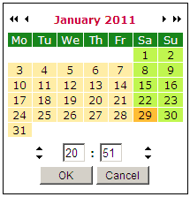 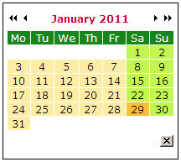

Drop Down Month-Year Navigation

Drop down navigation allows user to "hyper" jump between years. You can go back to the calendar of 10 years ago with just two clicks, you can't do that with arrow type navigation.

Typical application: Birth Date.

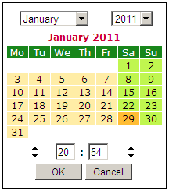 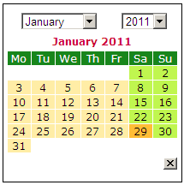

JavaScript Date Time Picker

File Level

Instance Level configuration allows you choose how you want it every time you call "NewCssCal" function. On the other hand, file level configuration applies to all "NewCssCal" instances in a web page.

File Level parameters are hidden in the JavaScript file, open the JavaScript file "datetimepicker_css.js" with your preferred text editor.

You will be able to find a block of variables in the first one hundred lines of code started with "Configurable parameters - start" and ended with "Configurable parameters - end".

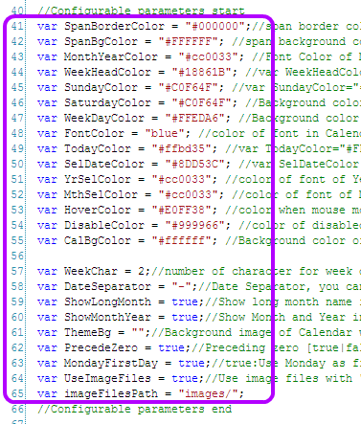

What circled in purple are parameters that you can customize to suit your own needs. The first half are color parameters that you can set and the other half are non-color parameters that you can play around with.

What appeared in the picture may not be what you have downloaded. As the program evolves, parameters might be added or removed, the picture above is only for illustration purpose.

//Configurable parameters - start  
var SpanBorderColor = "#000000";//Calendar border color  
var MonthYearColor = "#cc0033"; //Font Color of Month and Year in Calendar header.  
var WeekHeadColor = "#18861B"; //Background Color in Week header  
var SundayColor = "#C0F64F"; //Background color of Sunday  
var SaturdayColor = "#C0F64F"; //Background color of Saturday  
var WeekDayColor = "#FFEDA6"; //Background color of weekdays  
var TodayColor = "#ffbd35"; //Background color of today  
var SelDateColor = "#8DD53C"; //Backgrond color of selected date in textbox  
var YrSelColor = "#cc0033"; //color of font of Month-Year selector.Applies only for Arrow navigation  
var HoverColor = "#E0FF38"; //color of cell background when mouse move over  
var DisableColor = "#999966"; //color of disabled cell  
var CalBgColor = "#FFFFFF"; //Background color of Calendar window not cell  
  
var StartYear = 1940; //First selectable year  
var EndYear = 5; //The offset last year of pickable date.If current year is 2011, the last year that still picker will be 2016 (2011+5)  
var WeekChar = 2;//number of character for week day. if 2 then Mo,Tu,We. if 3 then Mon,Tue,Wed  
var DateSeparator = "-";//Date Separator, you can change it to "/" as you wish  
var ShowLongMonth = true;//Show long month name in Calendar header. example: "January"  
var ShowMonthYear = true;//Show Month and Year in Calendar header.Not applicable for Arrow navigation  
var PrecedeZero = true;//Preceding zero in date format  
var MondayFirstDay = true;//true:Use Monday as first day; false:Sunday as first day. [true|false]  
var UseImageFiles = true;//Use image files with "arrows" and "close" button  
var imageFilesPath = "images/";//Path of date time picker image files relative to HTML page  
//Configurable parameters - end

Besides customizing the appearance of the calendar, language of the calendar is also not hard coded. You can change the Month and Week name to your preferred language.

You may just locate the global array variable "MonthName", "WeekDayName1" and "WeekDayName2" and replace it in your own language.

//use the Month and Weekday in your preferred language.  
  
var MonthName = ["January", "February", "March", "April", "May", "June", "July", "August", "September", "October", "November", "December"];  
  
var WeekDayName1 = ["Sunday", "Monday", "Tuesday", "Wednesday", "Thursday", "Friday", "Saturday"];  
  
var WeekDayName2 = ["Monday", "Tuesday", "Wednesday", "Thursday", "Friday", "Saturday", "Sunday"];

I tried as much as I can to explain the purpose of the parameter by tailing a comment on each of the variable. If you still do not understand or you happen to detect a bug, please [email us](http://www.rainforestnet.com/contact.htm).